Listening Task: Making Pizzas

Task Description  You will listen to a story about Crazy Chris and Sensible Steve making pizzas at home. Listen to the story and answer the questions.  Follow the instructions in the Question-Answer Paper and the recording to complete the task. You will have one minute to read the questions before the recording begins. At the end of the story, you will have two minutes to tidy up your answers. | 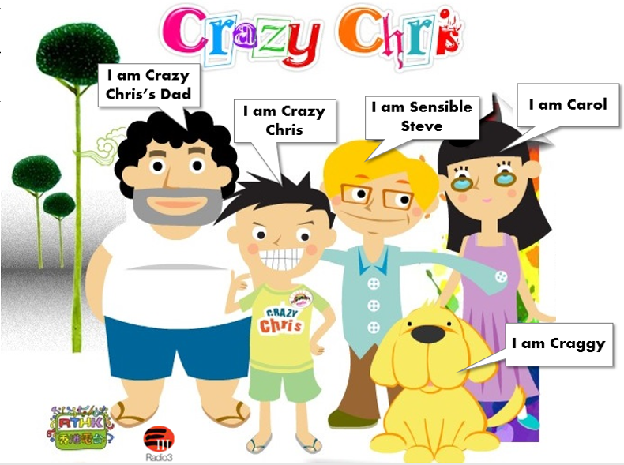

Answer Questions 1 – 10 by circling the correct answers.
(i) Before making pizzas
- How did Crazy Chris feel about making pizza?
 |  |  | 
A | B | C | D

- Who was going to be the judge?
 |  |  | 
A | B | C | D

(ii) While making pizzas
- What did Sensible Steve put on his pizza?
A | B | C | D

- How did Carol feel when Chris didn’t tell her the ingredients?
 |  |  | 
A | B | C | D

(iii) After the pizzas were cooked
- How did Steve feel when he introduced his pizza to Carol?
 |  |  | 
A | B | C | D

- How much of Steve’s pizza did Carol bite off?
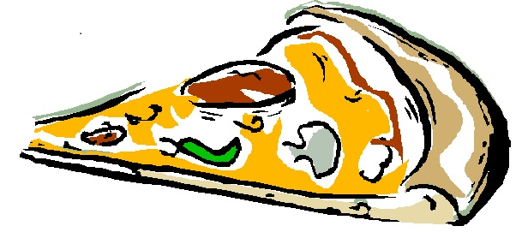 | 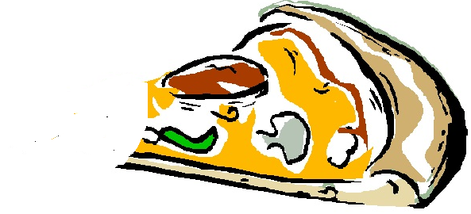 | 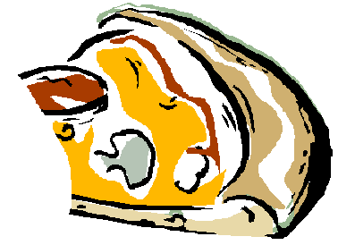 | 
A | B | C | D

- How did Carol feel after eating Steve’s pizza?
 |  | 
A | B | C | D

- How did Carol feel after biting Chris’s pizza?
A | B | C | D

- What did Chris put on his pizza?
A | B | C | D

- Carol shouted “It’s… It’s burning my mouth!” after biting Chris’s pizza. Which of the following can best describe the taste of his pizza?
- Sweet
- Sour
- Bitter
- Spicy

- Arrange the following pictures in the correct order by writing down 1–6 in the boxes provided. The first one has been done for you as example.

 |  |  | 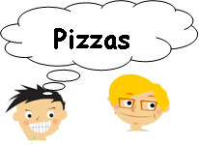 |  | 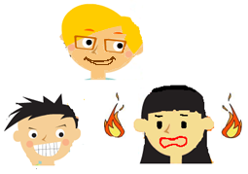
 |  | 1 | 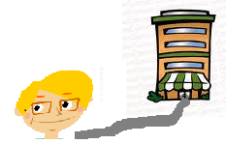 |  | 